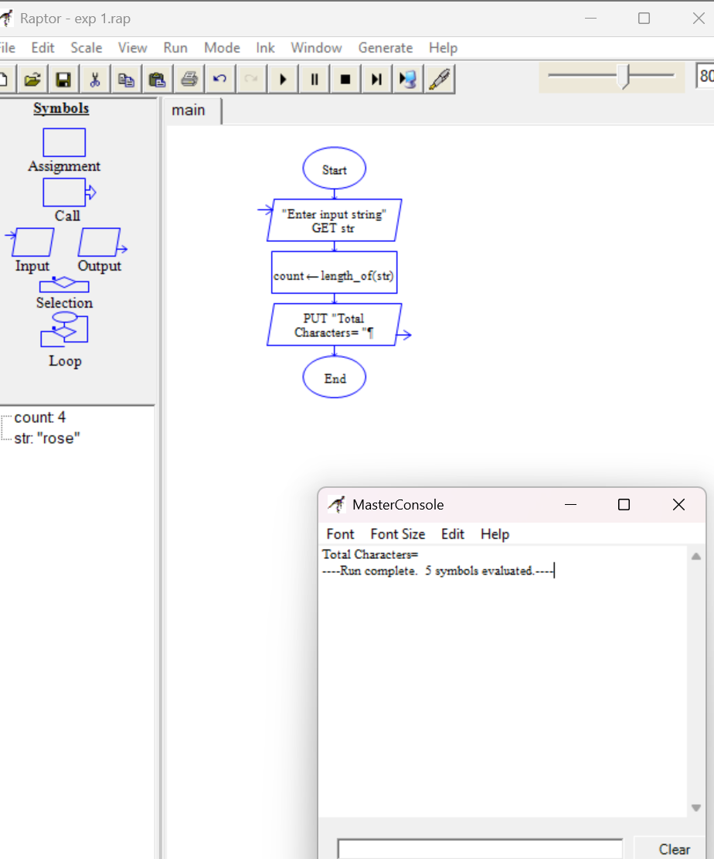
Exp 4 RAPTOR
ROSENIVITHA J 192424009
CSA1062 Software Engineering

